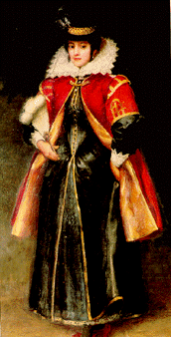
Comparing Sources about Pocahontas

We will look at different sources about the life of Pocahontas. The chart below helps you look at these sources critically by comparing and contrasting what they say. If a source agrees with a statement, put a plus (+) in the box. If it disagrees, put a minus (-). If the source does not address that issue, shade in the box. As you near the end of the unit, think of another statement that at least two sources comment on, add it at the bottom, and mark the chart appropriately.

Source Codes
A = “Pocahontas” by The Association for the Preservation of Virginia Antiquities
B = “Captain John Smith” by The Association for the Preservation of Virginia Antiquities
C = Pocahontas: Ambassador of the New World, A&E video biography
D = “The Pocahontas Myth” by Chief Roy Crazy Horse
E = Pocahontas (Disney movie)
F = “The Real Pocahontas” by David Morenus

Statement | A | B | C | D | E | F
1. “Pocahontas” was her real name.
2. Powhatan was a powerful ruler.
3. John Smith was a hero.
4. Smith was skilled at living under harsh conditions.
5. All the colonists liked John Smith.
6. Pocahontas was very young when she met Smith.
7. Pocahontas rescued Smith from certain death.
8. Pocahontas was in love with John Smith.
9. Smith was adopted into the Powhatan Indian tribe.
10. Smith was probably not in danger when he was
captured by the Powhatan people.
- Smith told everyone about his adventure with the
Powhatan Indians when he got back to Jamestown.
12. Pocahontas learned English from Smith.
13. Smith was seriously injured in a gunpowder accident.
14. Pocahontas helped make sure the colonists had food.
- The colonists kidnapped Pocahontas and held her for
ransom.
16. Pocahontas converted to Christianity.
17. Pocahontas married John Rolfe.
- Pocahontas traveled to England to help raise money
for the Virginia Company.
19. Pocahontas was very happy to see Smith in England.
20. Pocahontas died from a disease she caught in London.

Teachers have permission to use these materials in a classroom setting. Any commercial use without permission is prohibited.
Copyright 2000, Carla Beard

